Java Interview Questions – Collections & Exception Handling
PART 1: CORE COLLECTIONS
1. What is the difference between Collection and Collections in Java?
- Collection is an interface in java.util that represents a group of objects. It is the root interface for core data structures like List, Set, and Queue.
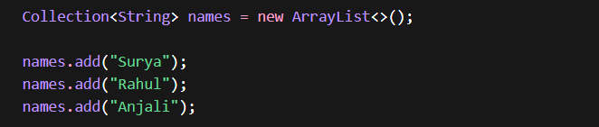
- Collections is a utility class that provides static helper methods such as sorting, reversing, shuffling, and creating synchronized collections.

Collection is used to store data, whereas Collections provides utility methods to operate on that data.

2. What is the difference between Iterator and ListIterator?
Both are used to traverse collections, but they differ in capability.
- Iterator
  - Works with all collection types
  - Supports only forward traversal
  - Can remove elements but cannot modify or add
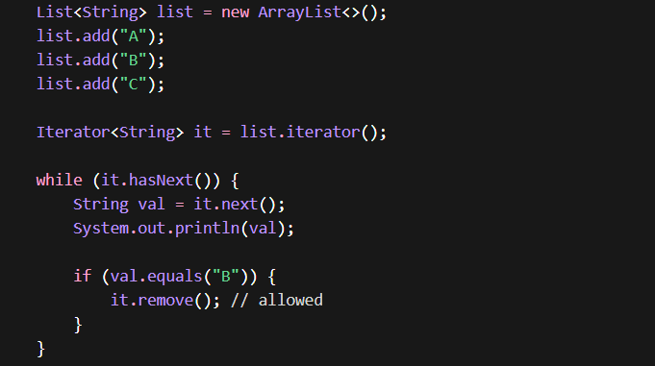
- ListIterator
  - Works only with List implementations
  - Supports both forward and backward traversal
  - Allows add, remove, and update operations during iteration
Use ListIterator when you need bidirectional traversal or modification while iterating.
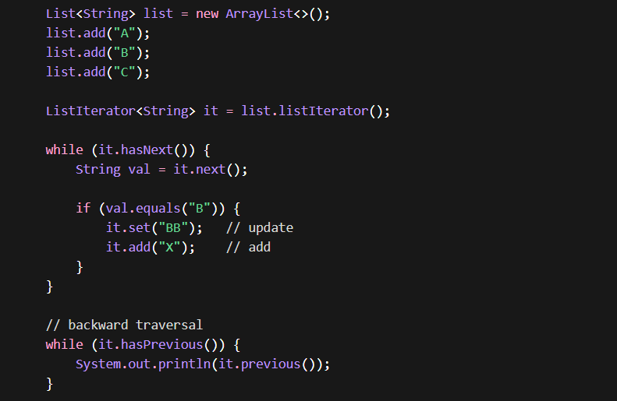

3. What is fail-fast vs fail-safe iterator?
- Fail-Fast Iterator
  - Works directly on the original collection
  - If the collection is modified during iteration, it throws ConcurrentModificationException
  - Detects changes using an internal counter called modCount (modification count); if it mismatches during iteration → exception is thrown
  - Example: ArrayList, HashMap
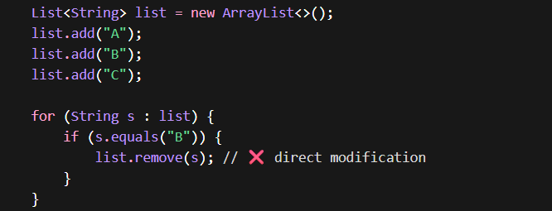
- Fail-Safe Iterator
  - Works on a clone (copy) of the collection Does not throw exception if collection is modified
  - Iteration happens on a snapshot of data, so any changes made after iterator creation may not be reflected during traversal
  - Example: ConcurrentHashMap, CopyOnWriteArrayList
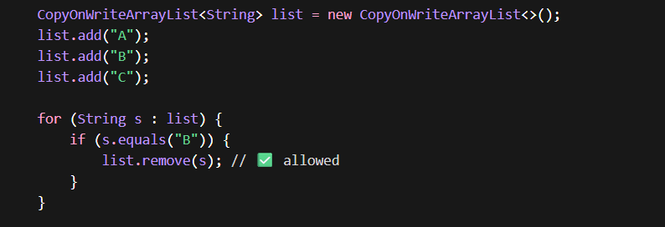
4. What is the difference between List, Set, and Queue?
- List
  - Maintains insertion order
  - Allows duplicates
  - Example: ArrayList
- Set
  - Does not allow duplicates
  - May or may not maintain order
  - Example: HashSet, TreeSet
- Queue
  - Follows FIFO (First In First Out)
  - Used for processing elements in order
  - Example: LinkedList, PriorityQueue

5. What is the difference between Iterable and Collection?
- Iterable
  - Root interface for iteration
  - Provides only one method: iterator()
  - Enables use of for-each loop
- Collection
  - Extends Iterable
  - Provides additional methods like add(), remove(), size()
“Iterable gives traversal capability, Collection adds storage and manipulation capabilities.”

6. Why do we need the Collections Framework?
The Collections Framework provides a standardized and efficient way to store, manage, and manipulate data.
Think of it like:
- Collection Framework → Entire kitchen 🍳 (system (interfaces + classes + utilities)
- Collection (interface) → Recipe book 📖 (Interface)
- ArrayList / HashSet → Actual dishes 🍲 (Classes – Implementations)
- Collections class → Tools (knife, mixer) 🔪 (Utility class)
7. Comparable vs Comparator?
Both are used for sorting but differ in approach.
- Comparable
  - Defines natural ordering
  - Implemented inside the class
  - Uses compareTo()
  - Allows only one sorting logic
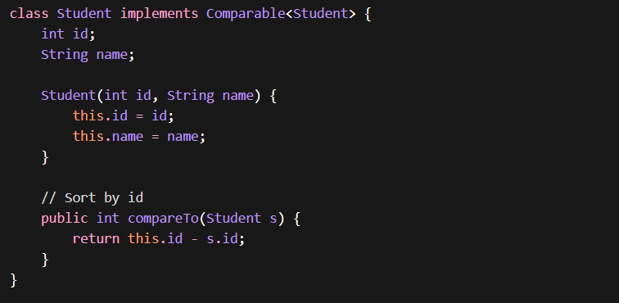
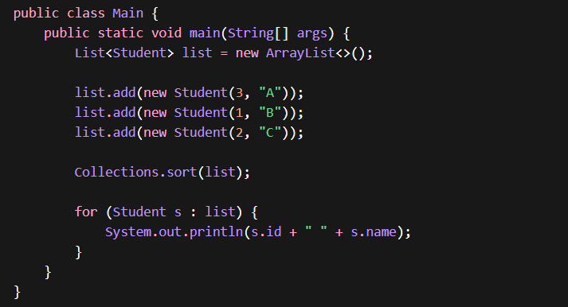
Comparable is for default sorting, Comparator is for flexible/custom sorting.”
- Comparator
  - Defines custom ordering
  - Implemented externally
  - Uses compare()
  - Allows multiple sorting logics
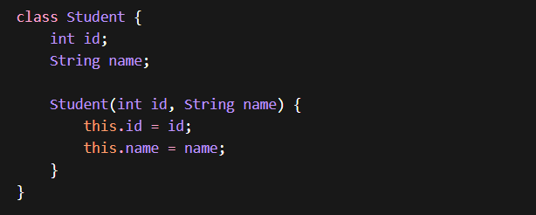
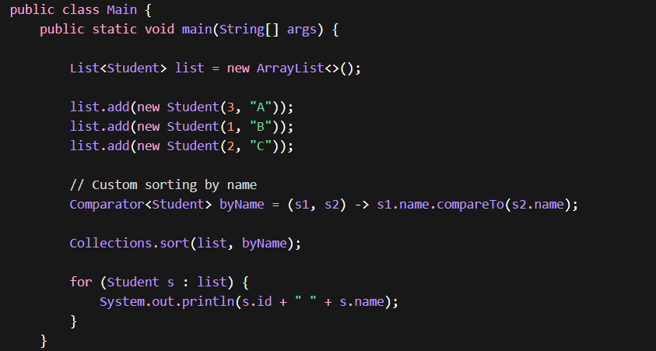
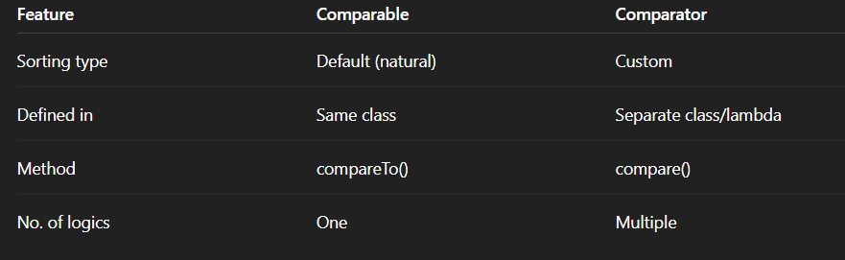

8. What is the difference between equals() and hashCode()?
These two methods are critical for collections like HashMap and HashSet.
- equals()
  - Checks logical equality of objects
  - Compares content (logical equality)
  - Returns true if objects are logically same
- hashCode()
  - Returns integer used to determine bucket location
  - Returns an integer value (hash)
  - Used in HashMap / HashSet for fast lookup
👉 If two objects are equal → hashCode must be same
“HashCode improves performance, equals ensures correctness.”
If equals() is true → hashCode() must be same
If hashCode() same → equals() may or may not be true

🧪 Part 1: String Example (No Override Needed)
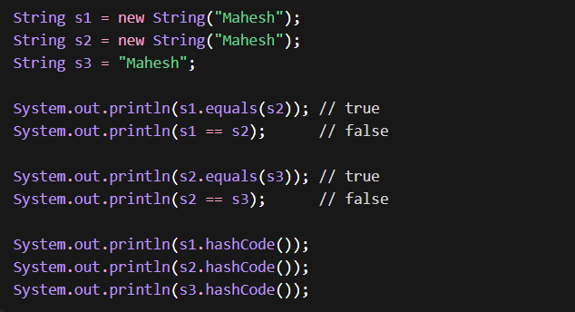
- equals() → compares values → ✅ true
- == → compares memory → ❌ false
- hashCodes → same (same content)

Custom Class WITHOUT Override
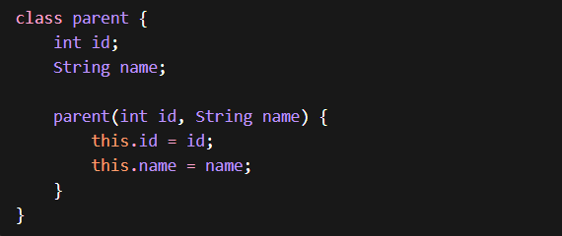
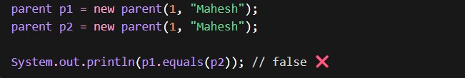
- Default equals() compares memory address
- So objects are different → ❌ false

🧪 Part 3: WITH Override (Your Code)
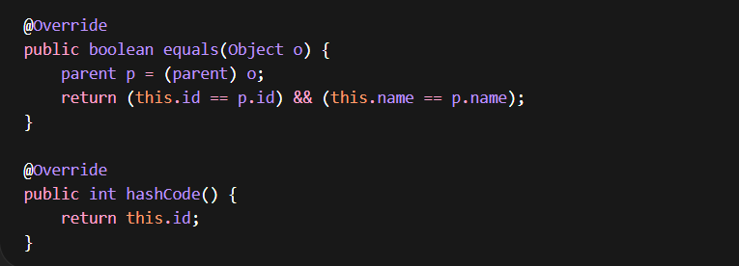
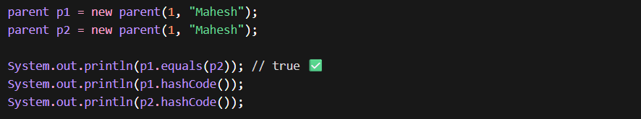 Now What Changed?
- equals() → compares id + name → ✅ true
- hashCode() → same id → same hash → ✅

Feature | equals() | hashCode()
Purpose | Compare objects | Generate hash
Return | boolean | int
Default behavior | Reference compare | Memory-based
Override needed | Yes | Yes

“equals() is used to compare object content, while hashCode() is used to generate a hash value for efficient storage in hash-based collections. Both must be overridden together.”

9. Why should we override equals() and hashCode() together?
Because collections like HashMap rely on both methods:
- hashCode() → finds bucket
- equals() → finds exact object
If only one is overridden:
- It leads to incorrect behavior (duplicates or missing data) .
“Overriding both ensures proper functioning of hashing-based collections.”
Overriding both equals() and hashCode() is not required for compilation, but it is essential to maintain the contract and ensure correct behavior in hash-based collections like HashMap and HashSet.
10. What is the difference between structural and non-structural modification?
- Structural Modification
  - Changes size of collection (add/remove)
  - Causes fail-fast behavior
- Non-Structural Modification
  - Updates value only
  - Does not affect structure
- add() → structural
- set() → non-structural

11. What is the difference between Array and Collection?
🔹 Array
- Fixed size (cannot grow/shrink)
- Can store primitives + objects
- Type-specific (homogeneous)
- No built-in methods (limited operations)
- Faster, less memory overhead
- Part of core Java (not framework)

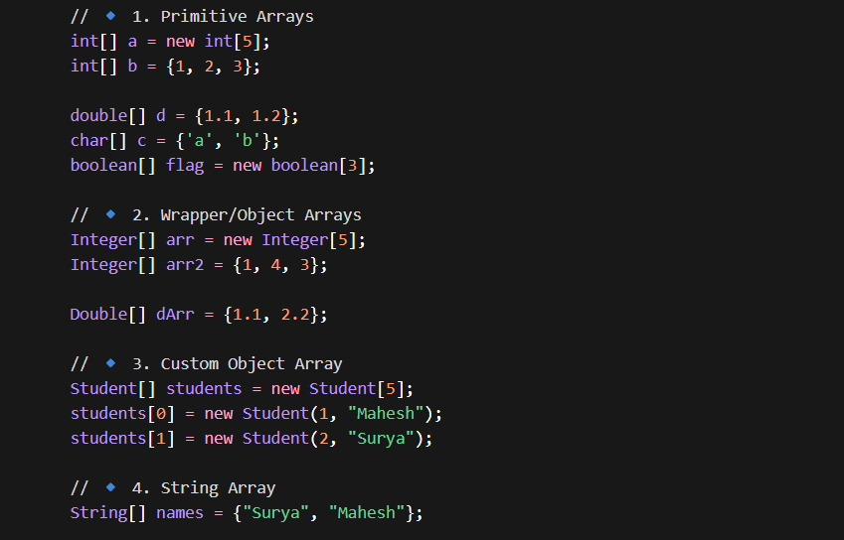
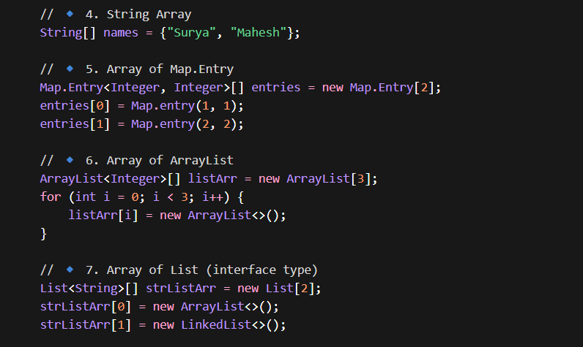
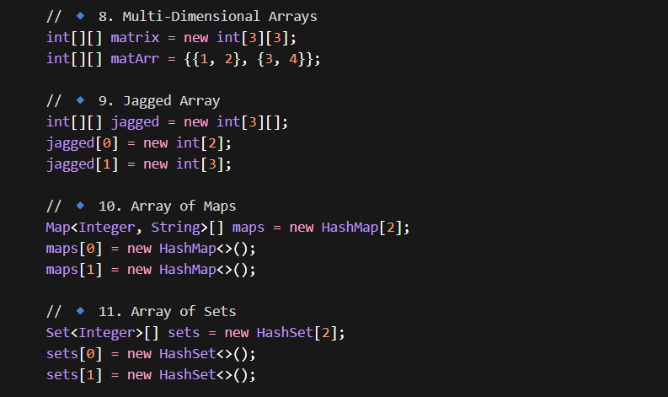
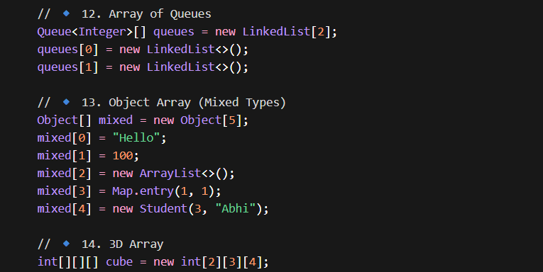
General form:

🔹 Collections
- Dynamic size (resizable)
- Store objects only (use wrappers for primitives)
- Use generics (type-safe & flexible)
- Rich APIs (add, remove, sort, etc.)
- Slightly slower (due to abstraction)
- Part of Java Collections Framework (JCF)
“Array is basic, Collection is dynamic and feature rich.”
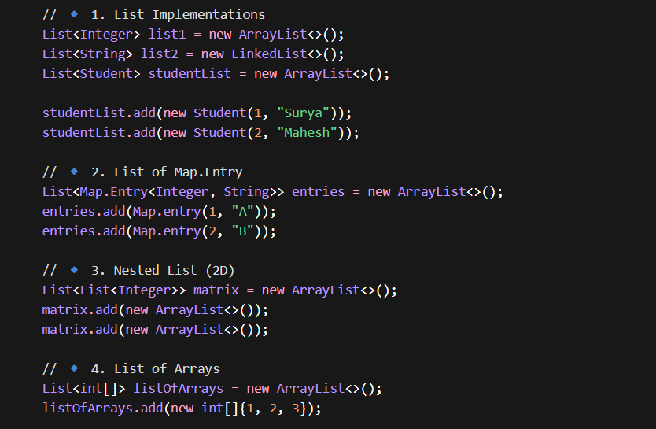
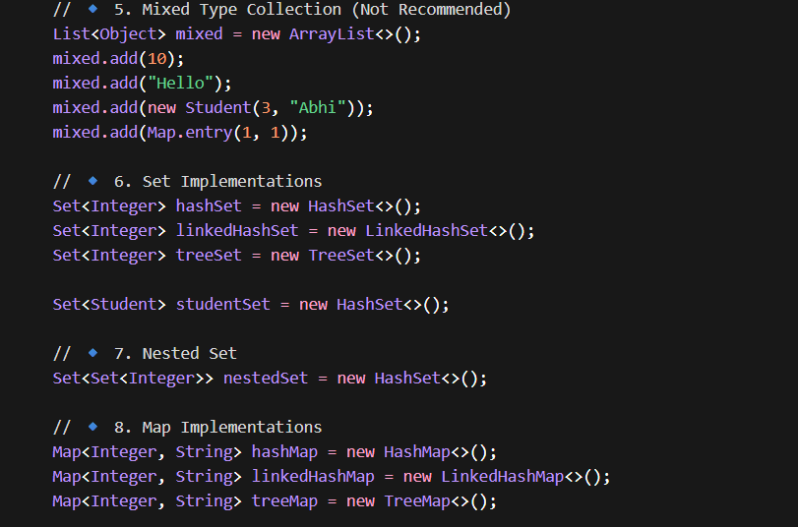
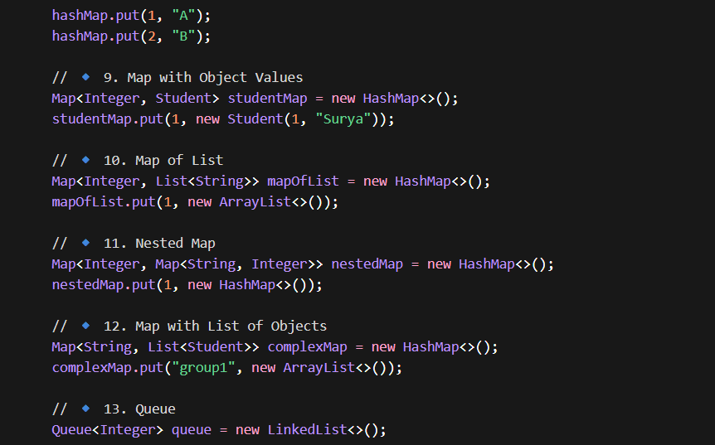

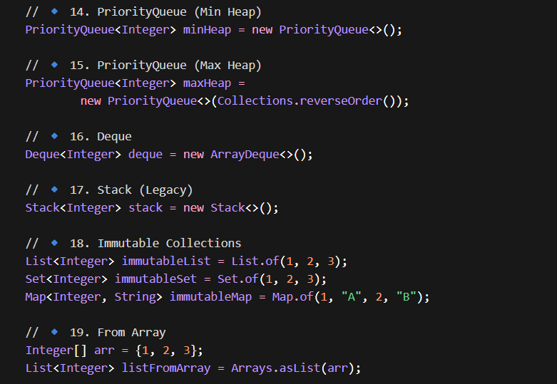
12. What are the main interfaces of Collections Framework?
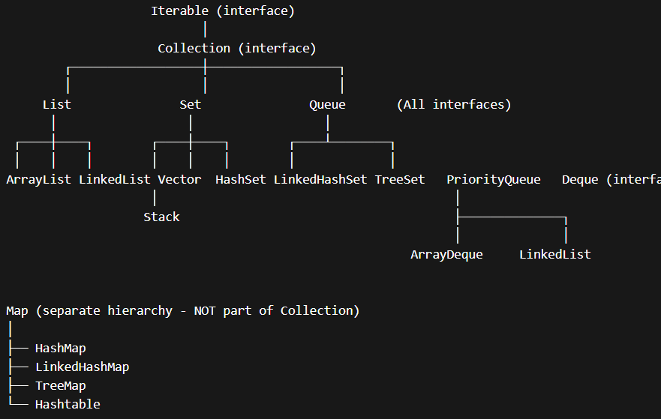
13. What is internal working difference between List and Set?
- List
  - Uses index-based storage
  - Allows duplicates
- Set
  - Uses hashing (HashSet) or tree (TreeSet)
  - Ensures uniqueness
“Set uses hashing to eliminate duplicates.”
14. What is the difference between modCount and ConcurrentModificationException?
- modCount
  - Internal counter tracking structural changes
- ConcurrentModificationException
  - Thrown when modCount changes during iteration
“Fail-fast behavior is implemented using modCount.”

PART 2: LIST + HASHMAP INTERNALS
1. What is the difference between ArrayList and LinkedList?
Both implement the List interface, but their internal structures are different.
- ArrayList
  - Backed by a dynamic array
  - Provides fast random access (O(1))
  - Insertions/deletions in middle are slow (shifting required)
- LinkedList
  - Uses a doubly linked list
  - Each node has data + next + prev pointer
  - Insert/delete is fast (O(1)) if position known
  - Access is slow (O(n)) due to traversal
“ArrayList is better for read-heavy opns, LinkedList is better for insert/delete operations.”

2. How does ArrayList grow internally?
- Initial capacity = 10
- When full:
  - New capacity = old + (old / 2) → ~1.5x growth
- A new array is created and elements are copied

3. Why is ArrayList resizing expensive?
- It creates a new array
- Copies all elements to new array
Time complexity: O(n)
This is why we use initial capacity if size is known.

4. What is the internal structure of LinkedList?
LinkedList is implemented as a doubly linked list.
Each node contains:
- Data
- Reference to next node
- Reference to previous node
It also maintains:
- Head pointer
- Tail pointer
“Traversal can happen in both directions, which is why it's doubly linked.”

5. When should you NOT use LinkedList?
Avoid LinkedList when:
- Frequent random access is required
- Memory is a concern (extra pointers per node)
“LinkedList has more memory overhead compared to ArrayList.”

6. What happens when you remove an element from ArrayList?
- Elements after the removed index are shifted left
- Size decreases by 1
- Time complexity: O(n)

7. What happens when you remove an element from LinkedList?
- Node is unlinked by updating pointers
- No shifting required
Time complexity: O(1) (if node reference is available)
8. How does HashMap work internally?
HashMap internally uses an array of buckets where each key is converted into a hash using hashCode(), and then mapped to an index. Each bucket stores entries as nodes.
In case of collisions, Java 7 uses a LinkedList, while Java 8 converts it into a Red-Black Tree if the number of nodes exceeds 8, improving performance from O(n) to O(log n). Retrieval uses hashCode() and equals() for key comparison.
- Key → hashCode()
- Hash is converted to index (bucket location)
- Entry stored as:
  - Node (key, value, hash, next)
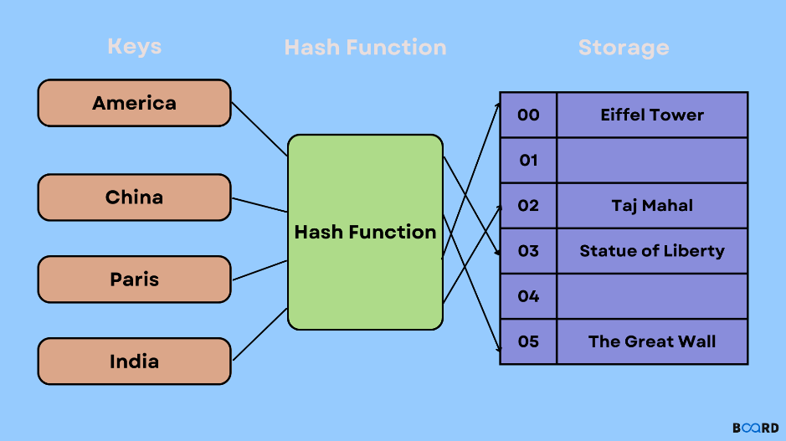
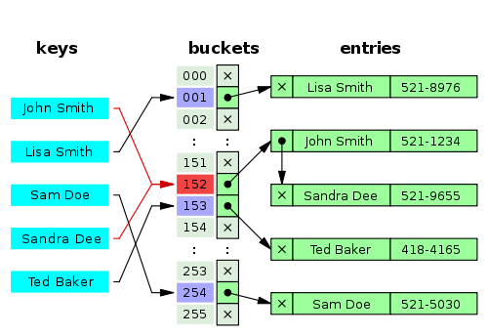
✅ GET Operation
- Compute hash
- Go to bucket
- Traverse:
  - LinkedList OR Tree
- Match using: equals()
✅ PUT Operation
- Compute hash
- Find bucket index
- If empty → insert
- If collision:
  - Traverse list / tree
  - Replace value if key exists
  - Else add new node
⚠️ Collision Handling:
If multiple keys map to same bucket:
- Java 7 → LinkedList
- Java 8 → LinkedList → Tree (if > 8 nodes)
Tree improves performance to O(log n)
“Hash → Index → Bucket → Collision → Tree”
⏱️ Time Complexity
Case | Complexity
Best | O(1)
Collision (LinkedList) | O(n)
After Treeify | O(log n)
9. How does get() method work in HashMap?
- Calculate hash of key
- Find bucket index
- Traverse bucket:
  - Compare using equals()
- Return matching value
Time complexity:
- Average: O(1)
- Worst: O(log n) (after tree conversion)

10. What is hashing and why is it used?
Hashing converts a key into a numeric value (hash) to determine storage location.
- Fast lookup
- Efficient storage
“Hashing enables constant-time complexity in average cases.”

11. What is collision in HashMap?
Collision occurs when:
Two different keys produce the same hash index
Collision Handling:
- Stored in same bucket
- Managed using:
  - LinkedList
  - Tree (Java 8+)

12. Why does HashMap use equals() and hashCode() both?
- hashCode() → finds bucket
- equals() → finds exact key
Without equals():
- Wrong value may be returned
Without hashCode():
- Performance degrades

13. What happens if hashCode is same but equals is false?
- Both objects go into same bucket
- Stored as separate entries
This is Collision Case : If two objects have the same hashCode but are not equal, they are placed in the same bucket but stored as separate entries.
HashMap handles this using a LinkedList (Java 7) or a Red-Black Tree (Java 8+).
14. What is load factor in HashMap?
Load factor determines when to resize HashMap (Default = 0.75)
Resize happens when size > capacity × load factor
Example:
- Capacity = 16
- Resize when size > 12

15. What is rehashing?
When capacity increases:
- New array is created
- All existing elements are rehashed and placed again

16. Why is HashMap not thread-safe?
- No synchronization
- Multiple threads can:
  - Overwrite data
  - Cause infinite loops (in older versions)

17. How does ConcurrentHashMap solve this?
- Uses fine-grained locking / CAS
- Does NOT lock entire map
- Allows multiple threads to work simultaneously
“ConcurrentHashMap improves performance by reducing lock contention.”

18. What is difference between HashMap and ConcurrentHashMap?
Feature | HashMap | ConcurrentHashMap
Thread-safe | ❌ No | ✅ Yes
Locking | None | Fine-grained
Performance | High (single thread) | High (multi-thread)

19. Why null keys allowed in HashMap but not in ConcurrentHashMap?
- HashMap → allows 1 null key
- ConcurrentHashMap → disallows null
- Avoid ambiguity in concurrent environment

20. What is difference between HashSet and HashMap?
- HashSet internally uses HashMap
- Stores elements as keys
- Value is dummy object
“HashSet is backed by HashMap.”

- “HashMap internally uses array + linked list + tree optimization”
- “ArrayList resizing is expensive but amortized efficient”
- “LinkedList trades memory for faster insert/delete”
- “ConcurrentHashMap uses fine-grained locking for scalability”

PART 3: EXCEPTION HANDLING
1. What is the difference between Checked and Unchecked Exceptions? Why does Java have both?
- Checked Exceptions
  - Checked at compile-time
  - Must be handled or declared using throws
  - Example: IOException, SQLException
- Unchecked Exceptions (RuntimeException)
  - Occur at runtime
  - Not mandatory to handle
  - Example: NullPointerException, ArithmeticException
Why both exist?
- Checked → For recoverable conditions (file not found, DB issues)
- Unchecked → For programming errors (null access, logic bugs)
“Checked exceptions enforce handling for expected failures, while unchecked exceptions represent developer mistakes.”
If the problem is outside your control → Checked Fix code not Handling by yourself.
If the problem is your mistake → Unchecked

2. Why is RuntimeException not mandatory to handle?
Because:
- These are programming errors
- Handling them doesn’t always make sense
- Fix should be in code, not in try-catch
Example:
- NullPointerException → fix null handling, not catch blindly

3. Can finally block be skipped?
Yes, in rare cases:
- System.exit() is called
- JVM crashes
- Infinite loop before finally
Otherwise, finally always executes.

4. What happens if an exception occurs in finally block?
- It overrides the original exception
- Original exception is lost (unless handled carefully)
This is why finally blocks should be kept minimal and safe.
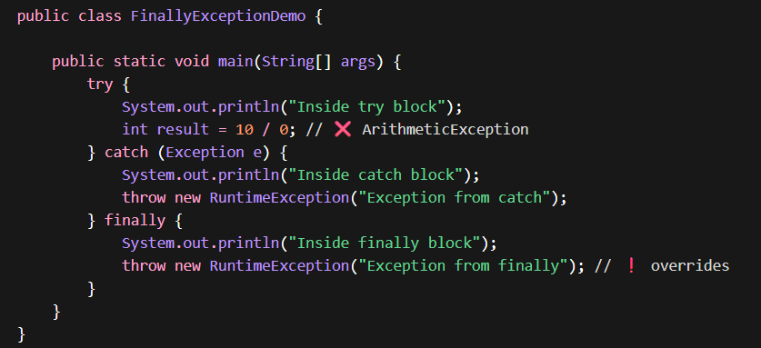
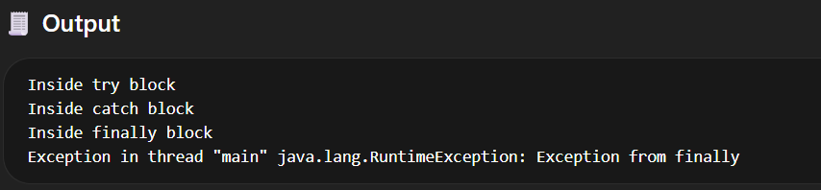
Explanation
- try → throws ArithmeticException
- catch → handles it and throws RuntimeException (from catch)
- finally → throws another exception
5. Difference between throw vs throws?
- throw
  - Used to explicitly throw an exception
  - Inside method
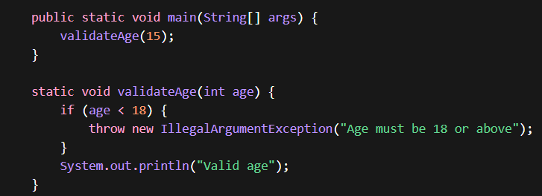
- throws
  - Declares exception in method signature
  - Delegates handling to caller
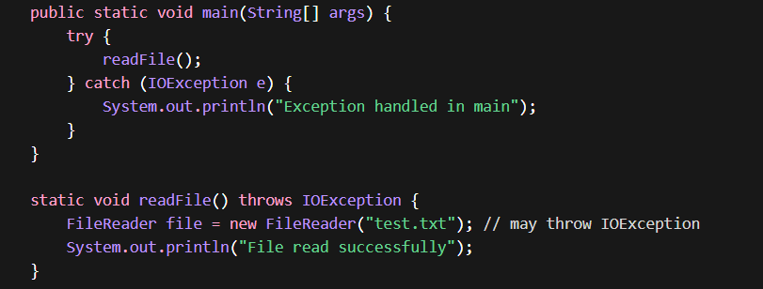
6. What is exception propagation?
When an exception is not handled in a method:
- It moves up the call stack
- Until it is caught or reaches JVM
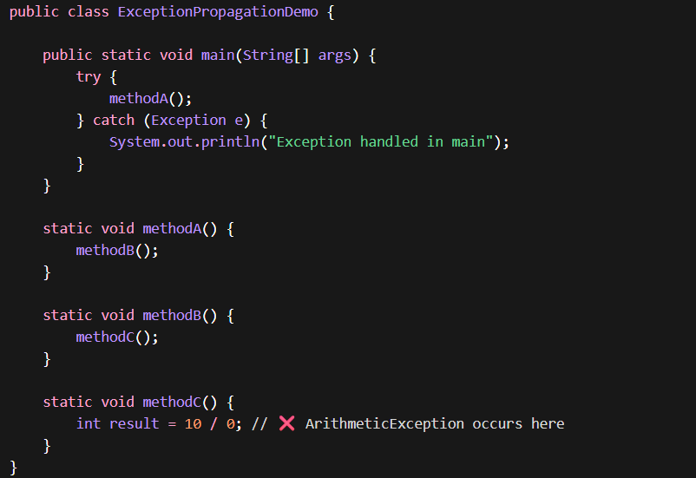
- main() calls → methodA()
- methodA() calls → methodB()
- methodB() calls → methodC()
Exception Occurs
- In methodC() → 10 / 0 → ArithmeticException
🔁 Propagation Begins
- methodC() does NOT handle → goes to methodB()
- methodB() does NOT handle → goes to methodA()
- methodA() does NOT handle → goes to main()
Finally Handled
- main() has try-catch → handles exception
What if NOT handled anywhere?
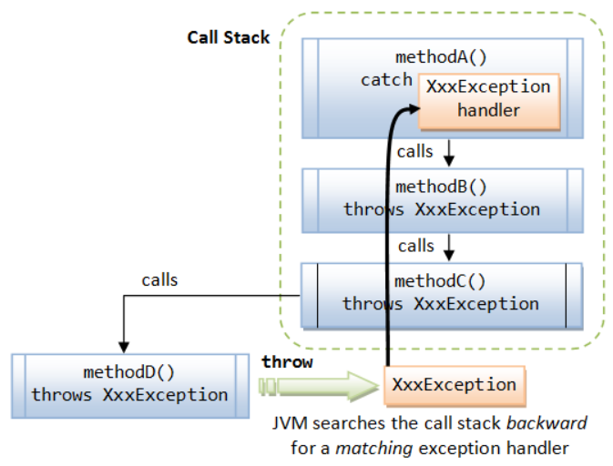
Stack trace is a snapshot of the call stack at the time of exception, showing method call sequence and exact failure location.
Stack trace is captured at the time of exception creation, which is why exception handling is expensive.
7. What happens if exception is not handled?
- JVM terminates the program
- Prints stack trace
Leads to application crash

8. Why is exception handling expensive?
Because:
- Exception object creation
- Stack trace generation
- JVM context switching
Performance impact is significant in high-frequency scenarios
“Exceptions should not be used for normal flow control.”
9. Why should we not use exceptions for normal flow?
- Slower than normal conditions
- Reduces readability
- Indicates poor design
- Ex: Using try-catch instead of null check

10. What is try-with-resources? Why is it better?
It automatically closes resources like:
- File streams
- DB connections
Why better?
- Prevents resource leaks
- Cleaner code
- No need for finally block
Internally uses AutoCloseable
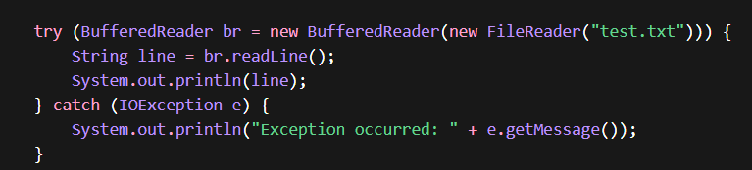
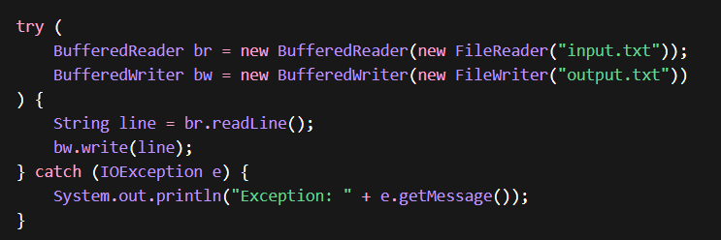
11. What is exception chaining?
Wrapping one exception inside another
Example:
- DB exception wrapped into Service exception

With Chaining:
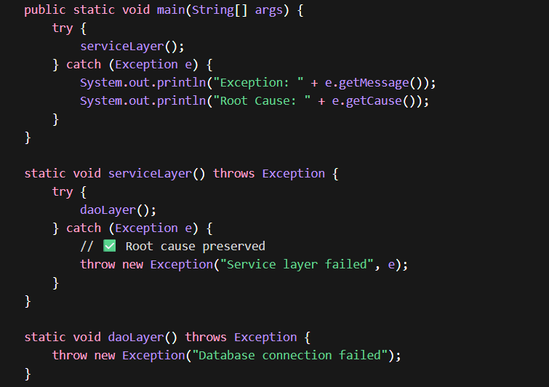
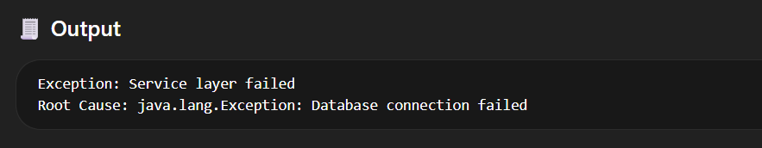

Without Chaining:
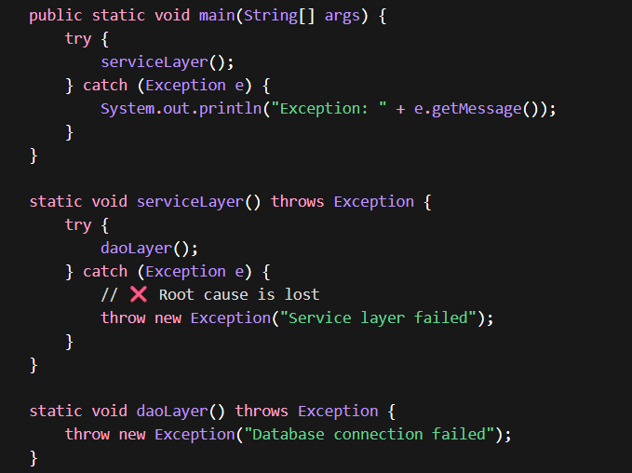
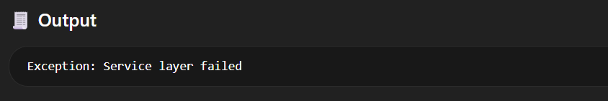
Problem
- You only see:
Service layer failed
- ❌ No idea what actually failed
- ❌ Root cause (DB failure) is completely lost

12. Difference between Error and Exception?
Exception → Problems your application can handle
Error → Problems your application cannot handle (JVM-level)
- Error
  - Serious JVM issues
  - Not recoverable
  - Example: OutOfMemoryError
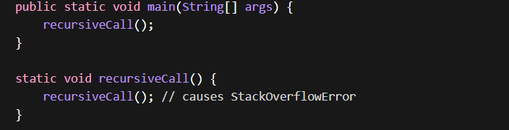
- Exception
  - Recoverable conditions
  - Can be handled
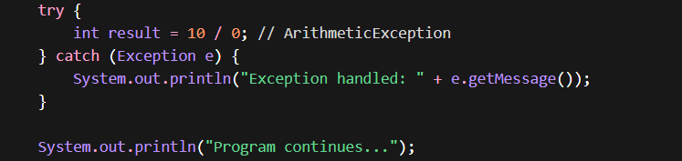
Never catch Error in normal applications

13. What is a stack trace?
It shows:
- Method call sequence
- Where exception occurred
Used for debugging root cause
Stack trace is a snapshot of the call stack at the time of exception, showing method call sequence and exact failure location.
Stack trace is captured at the time of exception creation, which is why exception handling is expensive.

14. Why should service layer throw exceptions instead of catching?
- Keeps business logic clean
- Allows centralized handling
- Avoids duplicate code
Controller layer or global handler should handle it

15. How do you handle exceptions in Spring Boot (real project)?
Using:
- @ControllerAdvice
- @ExceptionHandler
Flow:
- Exception occurs
- Handled globally
- Proper response returned

16. Business Exception vs Technical Exception?
- Business Exception
  - Expected
  - Example: “User already exists”
- Technical Exception
  - Unexpected
  - Example: DB connection failure
Separate them for better error handling

17. What are common mistakes in exception handling?
- Catching generic Exception
- Swallowing exceptions (empty catch)
- Using exceptions for flow control
- Not logging properly
- Not preserving original cause
18. What is a custom exception? Why use it?
User-defined exception for business logic
Example:
- InvalidUserException
19. How does JVM create exception objects?
- Exception is an object
- Created using new
- Stack trace attached automatically
Memory + CPU overhead involved

Use these:
- “Exceptions should represent exceptional scenarios, not control flow”
- “Global exception handling improves API consistency”
- “Checked exceptions enforce handling, unchecked indicate programming errors”
- “Exception chaining preserves root cause”

PART 4: ADVANCED EXCEPTION HANDLING
1. What are Suppressed Exceptions?
Suppressed exceptions occur when:
- One exception is already thrown
- Another exception happens while closing resources
Instead of replacing the original exception, Java suppresses the second one
Where it happens?
- In try-with-resources

2. Difference between final, finally, and finalize
- final
  - Keyword → used for constants, methods, classes
  - Prevents modification / inheritance
- finally
  - Block → executes after try-catch
  - Used for cleanup
- finalize
  - Method → called by GC (deprecated now)
  - Used for cleanup before object destruction
“final is a keyword, finally is a block, finalize is a GC-related method.”

3. Can we have catch without try?
❌ No — not possible
- catch must always be associated with a try block
- Otherwise, compilation error occurs

4. What happens if we place generic Exception before specific exception?
catch (Exception e) { }
catch (IOException e) { } // ❌ unreachable
This causes compile-time error
Reason:
- Exception already catches all types
- Specific block becomes unreachable
“Catch blocks must go from specific → generic.”

5. What is Rethrowing an Exception?
Rethrowing means:
Catching an exception and throwing it again
Example:
catch (Exception e) {
throw e;
}

5. When should we use Checked vs Unchecked Exceptions?
- Checked
  - Use when caller can recover
  - Example: File not found
- Unchecked
  - Use for programming errors
  - Example: NullPointerException
“Use checked for recoverable scenarios, unchecked for developer mistakes.”

6. Should custom exceptions extend Exception or RuntimeException?
- Extend Exception
  - If you want mandatory handling
- Extend RuntimeException
  - If it’s business logic or validation
- Most Spring Boot apps → use RuntimeException

43. What is the impact of excessive exception logging?
- Performance overhead
- Log flooding
- Hard to debug real issues
Best Practice:
- Log once at appropriate layer
- Avoid duplicate logging

44. How do you handle exceptions in Microservices?
- Use global exception handler
- Return standard error response
- Include:
  - Error code
  - Message
  - Timestamp
Also:
- Use centralized logging (ELK, etc.)
- Preserve root cause

45. Difference between throw new vs throw e
- throw e
  - Rethrows same exception
  - Preserves stack trace
- throw new Exception()
  - Creates new exception
  - Original stack trace is lost
“Rethrow preserves context, new exception resets it.”

46. How do you find the root cause of an exception?
Using:
e.getCause()
Keep calling until null
Why important?
- Helps identify real failure source

47. When to use Exception vs Validation?
- Validation
  - Expected scenarios
  - Example: empty input
- Exception
  - Unexpected failures
  - Example: DB failure

“Validation handles expected input errors, exceptions handle unexpected failures.”

48. Should we log and throw exception together?
Depends on layer:
- Lower layers → ❌ avoid logging
- Top layer → ✅ log once
Reason:
- Avoid duplicate logs

49. How are exceptions handled in threads?
- Exceptions do NOT propagate to main thread
- Must handle explicitly
Example:
- Use try-catch inside thread
- Or use exception handlers

50. Why avoid printStackTrace() in production?
- Not structured
- Not logged properly
- Hard to trace

